Experiment-1

CIRCUIT ANALYSIS :

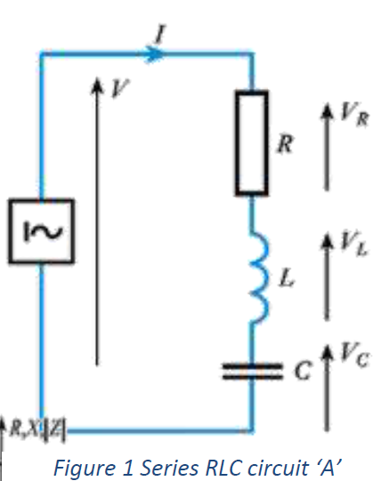**Q1.from figure 1:**

From graph:

FR =50.0032Hz

F1=55.22Hz

F2=45.2373

I=0.25A

Vr=14.016V Vc=69.159V Vl=71.038V

Bandwidth=55.22-45.23=9.69Hz

Q-factor=50/9.69=5.16

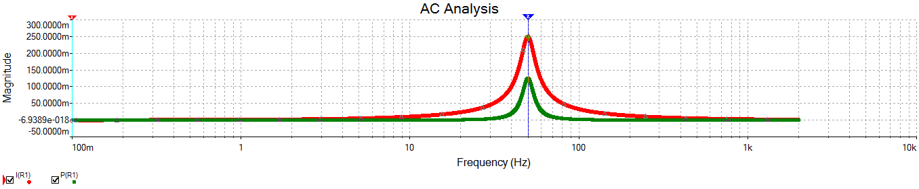

**Q2.from figure 2:**



Fr=0Hz

Bandwidth=Infinty

Q-factor=0

I=0.1A , Vr=10V , Vc=10V , Vl=0V

**SIMULATION :-**

**Circuit simulation of A**:



**Parameter settings :-**

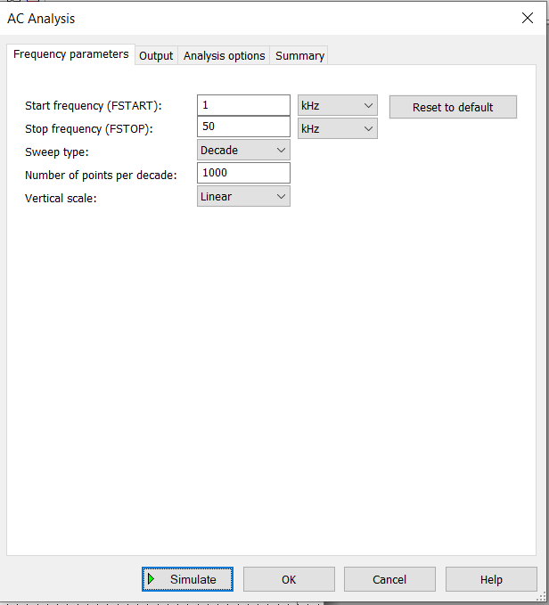

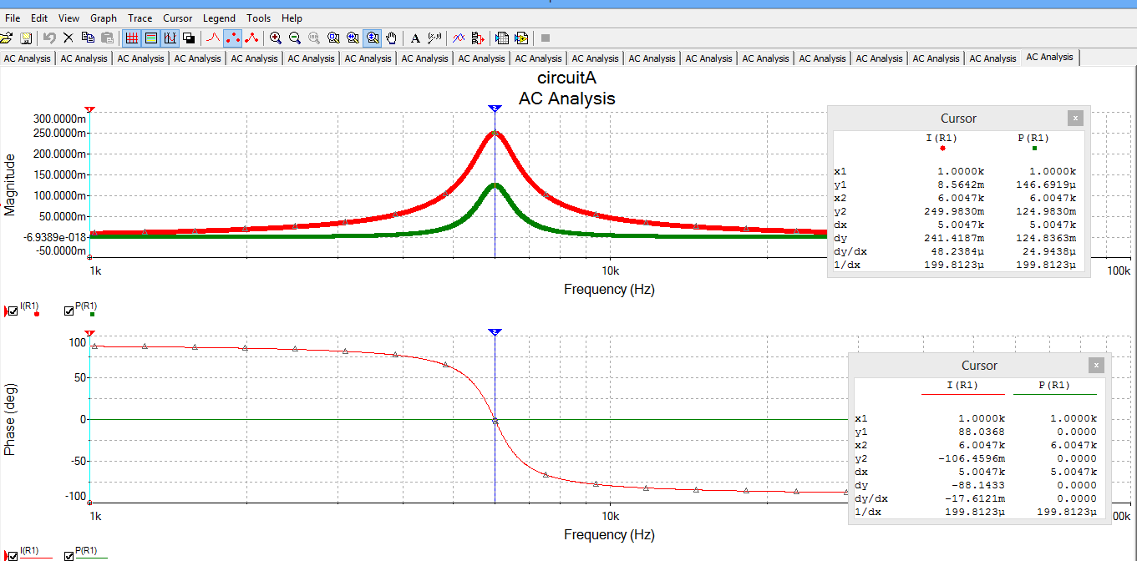

* It is simple series RLC circuit.

**Circuit simulation of B:**



**Parameter settings :-**

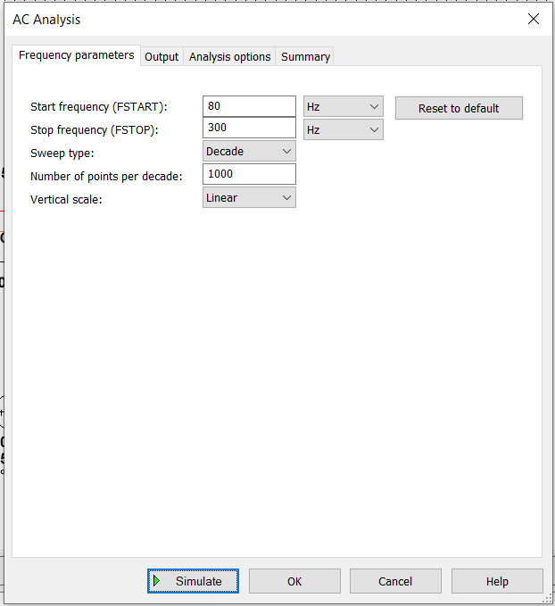

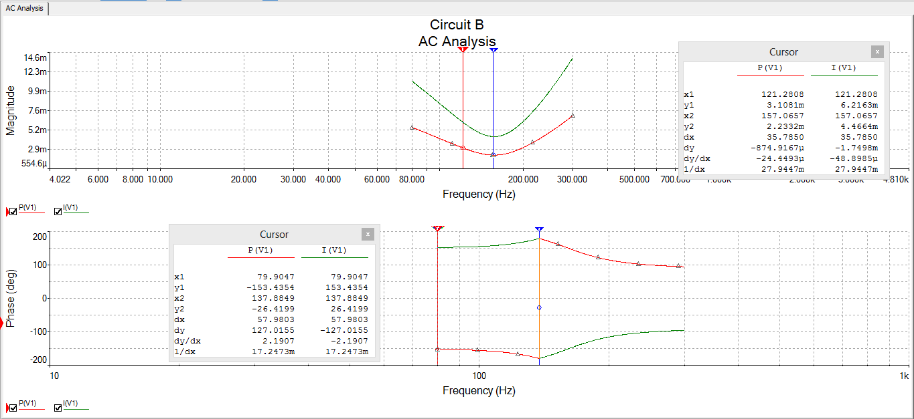

* This is parallel AC circuit.
* Here the calculated resonating frequency with 100ohm resistance is 0 , which is not a characteristic of a AC circuit.
* Here in parallel circuits we need to calculate double the minimum power frequency instead of half Power frequency.
* So to bring the circuit to resonating condition , we replaced the 100 ohm resistance with a potentiometer(100 ohm) working at 50% .the readings were recorded as per the graph obtained after simulation.

**Circuit simulation of C:**



**Parameter settings :-**

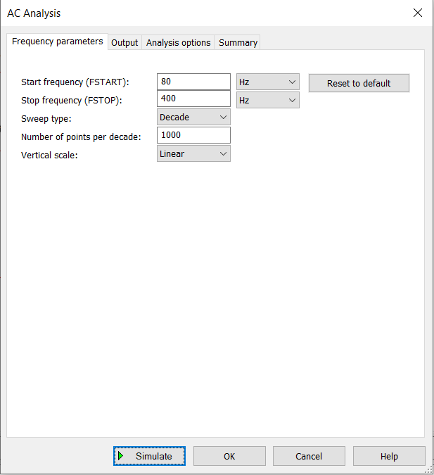

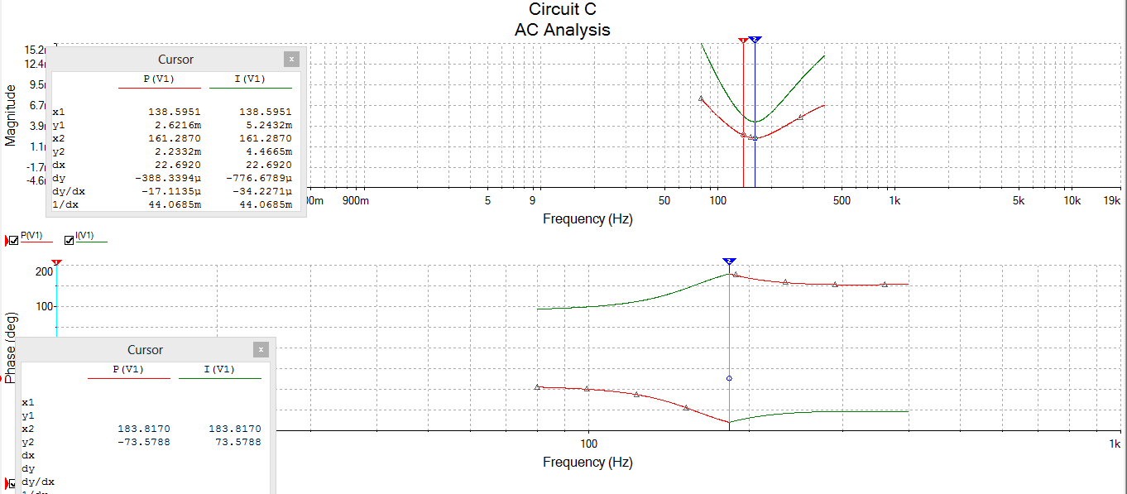

* This is parallel AC circuit.
* Here the calculated resonating frequency with 100ohm resistance is 0,which is not a characteristic of a AC circuit.
* Here in parallel circuits we need to calculate double the minimum power frequency instead of half Power frequency

So to bring the circuit to resonating condition,we replaced the 100 ohm resistance with a potentiometer(100 ohm) working at 50% .the readings were recorded as per the graph obtained after simulation.

**Circuit Simulation of D:**

**Parameter settings :-**

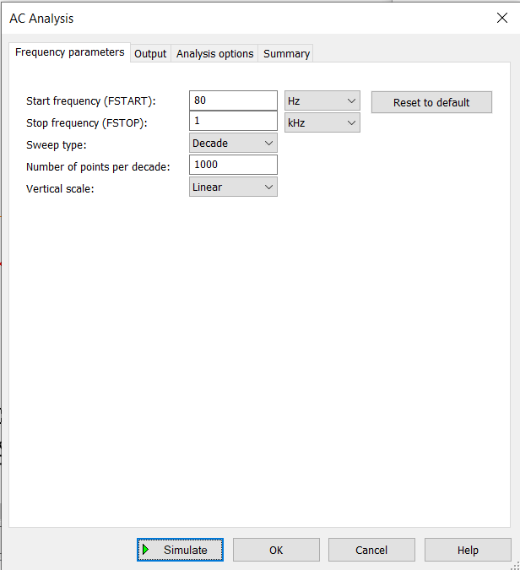

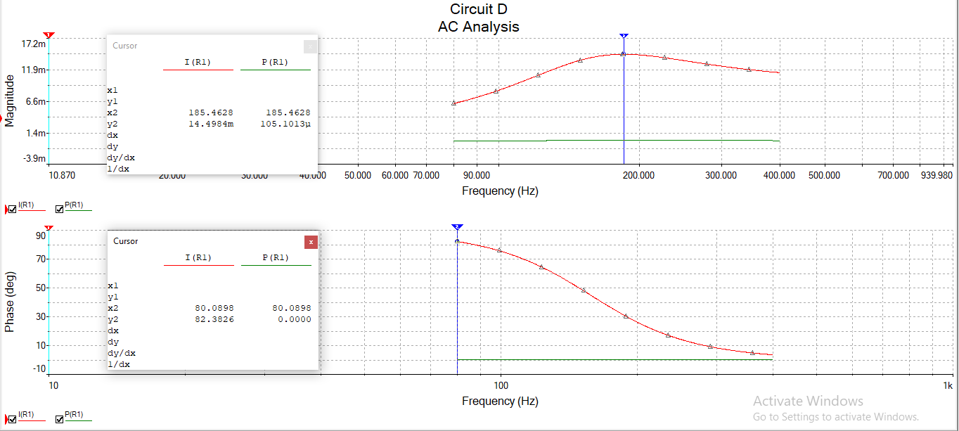

|  |  |  |  |  |  |  |  |  |  |
| --- | --- | --- | --- | --- | --- | --- | --- | --- | --- |
| CIRCUIT | RESONATING  FREQUENCY | HALF POWER  FREQUENCY | | BANDWIDTH | Q FACTOR | PARAMETERS AT  RESONANCE | | | |
| F1 | F2 | Current | VR | VL | VC |
| A | 5.9979khz | 5.4329khz | 6.6342khz | 1201.75 | 0.7943 | 3.51A | 14.041V | 71.026V | 69.339V |
| B | 157.0657Hz | 96.463Hz | 234.91Hz | 138.289 | 0.18 | 0.032A | 3.163V | 6.324V | 7.071V |
| C | 161.28Hz | 107.79 | 262.65 | 154.65 | 0.166 | 0.032A | 68.679V,3.229V  R1 R2 | 7.071V | 6.291V |
| D | 225.4061Hz | 174.9360Hz | 383.0876Hz | 208.150 | 0.17 | 0.098A | 98.199V(R1);  8.056V(R2) | 8.056V | 6.844V |

Observation Table

**Q2.** *What happens if circuit C is simulated with R (which is in series with L) removed?*

**Answer :** Using simulation , we found that we obtained resonating condition at frequency:161.58Hz when resistance was removed.

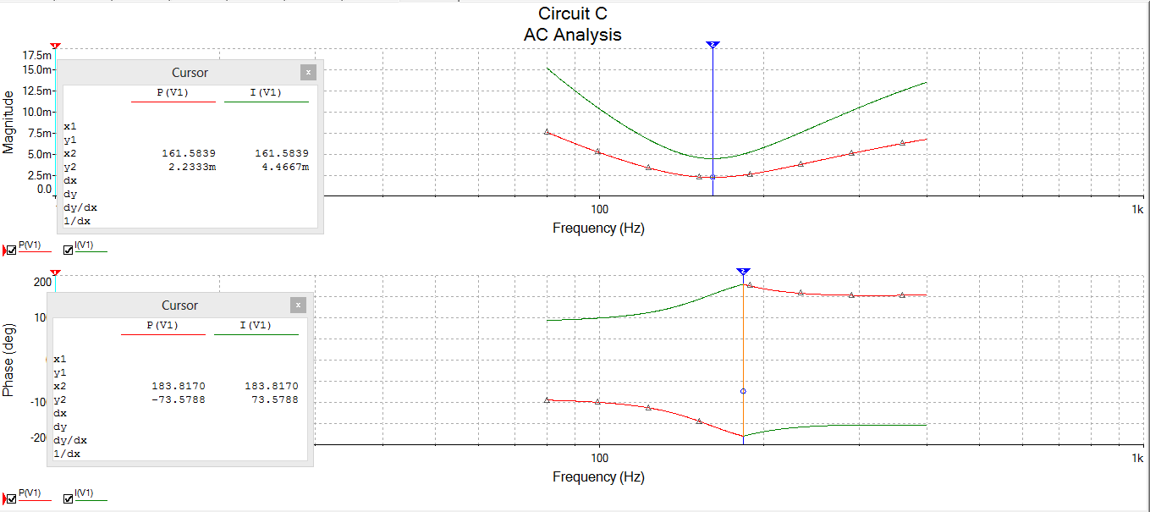

**Q3:** *Discuss how the phase diagram can be used to determine the power of the circuit or*

*nature (Reactive/resistive/ capacitive) of the circuit?*

**Answer:** From phasor diagram we can conclude that :-

If current and voltage are in same phase then it is a resistive circuit.

If current leads voltage then it is a capacitive circuit.

If voltage leads current then it is a inductive circuit.